

**Job Description**

**Role:** **Assistant Centre Manager**

**Reporting to:** **Centre Manager**

**Key Relationships:**  Business Centre Teams / Clients

**Location:** **Watford**

**Contract:** **£29,500 Full Time, Permanent**

**Hours: Monday – Friday 08.30 –17:00, 37.5 hours per week**

**Who are we and what do we do?**

Wenta is the leading, independent social enterprise that provides inclusive support for everyone to start and run a successful, greener business. Our team is experienced, impartial and independent with **no** shareholders. We own and operate business centres, co-working space and light industrial units across Hertfordshire and North London as well as provide a variety of business support from one-to-one business advice to skills training. Wenta help people with free, unlimited, personalised, tailored business support and skills training particularly for those who face barriers. We make it easier, simpler and greener to start and run a business with our accessible, practical advice and affordable workspace.

Over the past six years, Wenta has seen rapid growth across all its services, moving from a local brand to national and we’re proud to say that Wenta is now one of the largest enterprise agencies in England.

Our rapid growth now means that we are looking for a highly driven, client and sales-focused Assistant Centre Manager at Watford Centre.

**Key Purpose of Role**

The purpose of this role is to proactively support the Centre Manager in creating and building relationships with business owners and delivering the following:

* Excellence in client sales acquisition and retention
* Excellence in facilities management
* Excellence in customer services always ensuring high quality standards

To support the Centre Manager in the following:

* To proactively acquire and retain clients
* To provide first-class, customer service across all of Wenta’s communication channels from Reception Desk to phones, email and online
* To successfully manage the day-to-day running of the business centre To drive and support our digital income growth as well as other income streams for the centre

**Key Responsibilities**

Client Acquisition

* To support the Centre Manager in delivering the strategy of acquisition with effective planning and time management:
  + Developing plans with the Centre Manager and Head of Business Centres to proactively seek clients, achieving full occupancy
  + Liaising and developing relationships with brokers and key referral networks, communicating latest workspace availability, meeting rooms, virtual office services and events
  + Arranging and conducting client viewings and negotiations
  + Keeping the company’s CRM system up to date with accurate and quality client data, reviewing insights and trends
  + Driving and supporting Wenta’s digital strategy, focusing on deriving new income streams
  + Collaborating with Wenta’s business advisors and advice team to ensure all Wenta’s services are promoted and communicated to all clients including:
    - Virtual mailboxes
    - Meeting rooms
    - Incubator/Collaboration station space for start-up businesses
    - Free business advice and skills training support
    - Sustainable business advice (Action Zero)
    - New products, programmes and services
  + Collaborating with Wenta’s Digital, Communication and Marketing (DCM) team on developing social media campaigns to promote the centre, creating and communicating on-brand, client business stories, centre news stories and key client updates for PR purposes
  + Raising awareness across the local stakeholder community, supporting the Centre Manager and Head of Centres with stakeholder relations

Client Retention

* To support the Centre Manager in delivering the strategy of acquisition with effective planning and time management:
  + Collaborating with Wenta’s business advisors and advice team to ensure all Wenta services are promoted and communicated to all clients
  + Creating and maintaining a consistent professional relationship with centre clients to understand their current business needs, sharing insight internally
  + Following The Code of Confidentiality and Impartiality, remaining independent from any client’s business ventures with no direct involvement

Customer Service

* To support the Centre Manager in delivering the strategy of customer service with effective planning and time management:
  + To schedule a visit to at least three clients per week and gain insight into their experiences, using this insight to provide the Head of Centres with regular client news stories and ways to improve customer experience within the centre
  + To proactively manage all client requests and complaints within one day ensuring that all client expectations are met and that a high standard of customer service is always delivered

Operations

* To support the Centre Manager in the following areas with effective planning and time management:
  + Reporting / data management / compliance
  + Managing and monitoring KPIs monthly
  + Facilitating the progress and sign off for planned works
  + Ensuring that the centre conforms to legislation relating to health and safety
  + Overseeing the production of sales, services and rent invoice to clients
  + Overseeing the process of and resolving all local direct debits and chase non-payments
  + Managing client expectations on the centre’s annual rental increase
  + Ensuring all client documentation is processed in order with GDPR regulations within one month of moving in, and to include the following:
    - PAT Certificates
    - COSSH Certificates
    - Insurance documents
    - Fire Marshal details
    - Emergency contacts
    - Certificate of Incorporation
  + Ensuring that all virtual clients adhere to Anti-Money Laundering Regulations
  + Conducting a weekly tour of the building and external areas to ensure everything is in good order and support by written documentations
  + Acting as a First Aider and Fire Warden for the site (after attending training)
* Client Operations
* Occupied units to have relevant service orders as per client needs e.g. broadband, telephone etc
  + All empty units to be kept clean and tidy in readiness for client viewings
  + Conduction of client exit interviews and agree any remedial work
  + Management of the meeting room booking process and ensure all equipment is in good working order
  + Providing a first point of contact for visitor and clients to the centre
  + Answering the phone to Wenta clients and virtual clients
  + Managing incoming and outgoing post
  + Dealing with all general, day-to-day enquiries from clients of occupied units
* Self-development / Collaboration
  + Assisting the Centre Manager in preparing the annual budgets and the development of income for Wenta
  + Working on individual projects with the Centre Manager and wider Wenta team
  + Exceeding and maintaining all standards of quality as required contractually by Wenta and as stated in the Wenta Client Charter
  + Attending and contributing to the various internal and external meetings and to be involved in other activities as requested by Wenta and the Senior Management Team

**The list of above duties is not exhaustive, and you may be required to carry out other duties which are not listed above as and when requested by their Line Manager.**

**Travel**

This role may require regular travel between our sites in Hertfordshire and North London, therefore a driving licence and transport are required to fulfil this role. Wenta has committed to the UK SME Climate Hub commitment and provides staff that purchase a battery powered car with an additional annual payment supplement of £1000*, please see company policy for more details.

**Person Specification**

|  |  |  |
| --- | --- | --- |
| **Knowledge and Experience** | **Essential** | **Desirable** |
| Experience in collaborating and building strong relationships with various stakeholders, partners and clients | **x** |  |
| Experience in communicating with clients through multiple channels including digital (telephone, email, web chat and Microsoft Teams) | **x** |  |
| High level of commercial awareness and sales background | **x** |  |
| Financial Literacy |  | **x** |
| Strong knowledge of Microsoft Office 365 and Dynamics CRM system |  | **x** |
| Customer service managerial experience in a managed workspace / business centre environment |  | **x** |
| Experience in client acquisition and retention | **x** |  |
| 2 years minimum managerial experience | **x** |  |
| **Skills and abilities** |  |  |
| Be able to take ownership of issues as they arise and provide a solution to your manager | **X** |  |
| Strong communication and interpersonal skills with the ability to effectively communicate with a wide range of individuals in a diverse environment. | **X** |  |
| Able to prioritise workload with conflicting requests for resources. | **X** |  |
| Ability to negotiate | **x** |  |
| Proficient IT skills including Microsoft Office 365 and ability to learn new systems |  | **x** |
| The ability to work flexibly within a small team and have a positive “can do” attitude. |  | **x** |
| Be self- motivated, proactive as well as reactive to activities | **x** |  |
| Ability to regularly input improvements and come up with initiatives that contribute to the success of the Business Centres | **x** |  |
| Take pride in a reliable and consistent work ethic that only improves under pressure | **x** |  |
| Strong organisational and time management skills | **x** |  |
| Strong digital research and communication skills to find and build new sales leads | **x** |  |

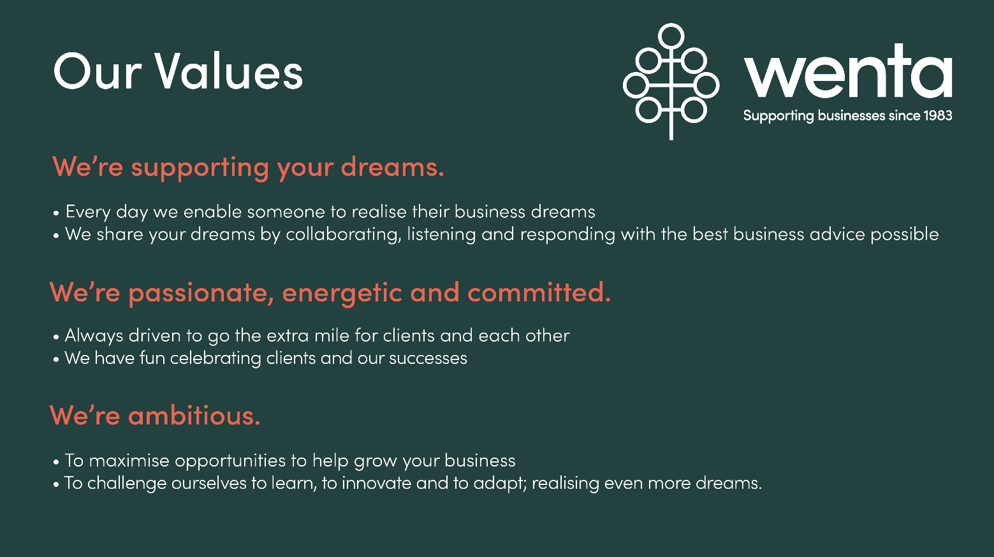

**What's in it for you?**

**Working at Wenta**

* **Passion**

Passion runs in the blood of Wenta employees. We are a team of passionate do-gooders, inspired to help small businesses and entrepreneurs reach their potential. Work alongside other motivated people who care about making a difference and achieving a shared vision.

* **Social events**

We’re a friendly bunch at Wenta. We hold at least one Wenta social event every year, be it a Christmas party or summer BBQ. In addition, our teams have regular social events as well as frequent community events which are great opportunities to meet, and network with, our customers and colleagues.

* **Holidays! +**

8 bank holidays per year plus 30 days of annual holidays reviewed annually (25 days are contractual not including Bank Holidays) which includes a closed office over the Christmas period. Plenty of time to rejuvenate and relax. We also provide life assurance (2 x annual salary), pension, season ticket loans, professional subscriptions, free eye tests and flu vaccinations.

* **Training and development**

We are committed to the ongoing training and development of all our employees and employees have access to our Wenta training courses too. We invest in our people and our people invest in us.

* **Strong leadership**

We are led by a strong board of non-executive directors and Senior Management Team who are dedicated to making a difference to the small business community. Each an expert in their particular field, our board has a comprehensive variety of expertise and ensures Wenta’s social purpose is first and foremost in everything we do.

* **Making a difference**

Be part of a social enterprise that changes people’s lives. Working at Wenta, you will be helping passionate entrepreneurs and start-ups make their dreams come true; it’s a special vision to be a part of and Wenta is a unique place to work.